
Cloudli Connect Training
How to review SMS Logs
Lynn Daviault | 11/5/25 | Cloudli Connect Training

How to review SMS Logs
This guide provides a straightforward process for reviewing SMS logs, making it easy for users to access and analyze their messaging data.

- Click “Telephony”
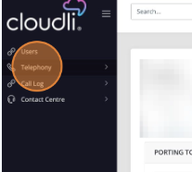

- Click “SMS Number”
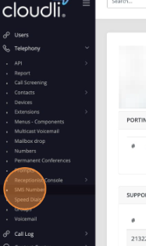

- Search for User or SMS number by entering the data in this field
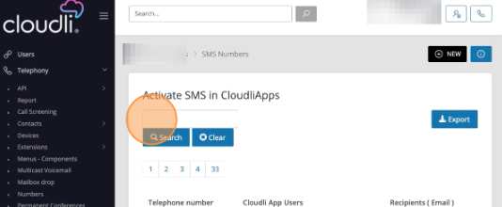
- Click the Telephone Number
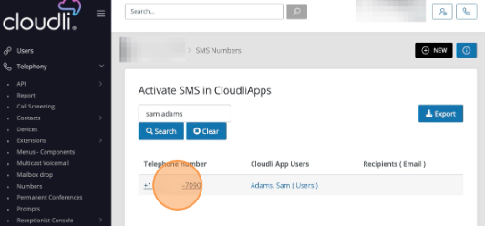

- Click the down arrow on the Menu Button
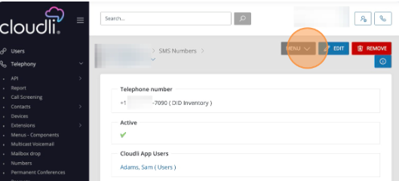

- Click “SMS Logs”
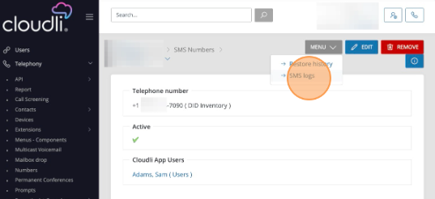

- Select the desired data range
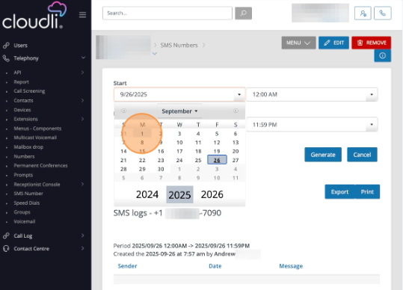

- Click “Generate”
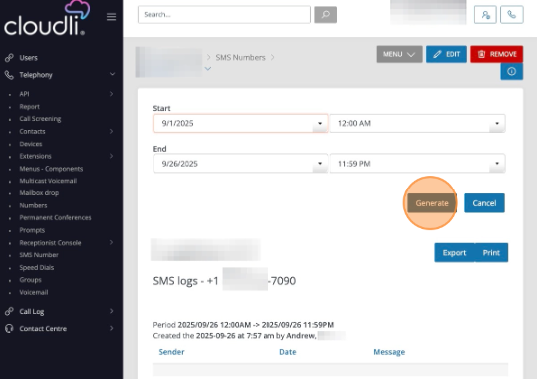

- Click “Export” to download the logs
